Potential Output and Cyclical Dynamics in a Policy-Constrained Small Open Economy
Abstract
This paper estimates potential output, the output gap, trend growth, and the natural real interest rate in Bosnia and Herzegovina using a semi-structural Laubach–Williams–style state-space model adapted to a currency board regime. The key contribution is to modify the canonical LW framework by removing a domestic policy reaction function and allowing cyclical dynamics to be driven primarily by external financial conditions and a time-varying risk premium. To validate the model-based cyclical decomposition, the paper also constructs alternative output-gap measures using univariate statistical filters and a production function approach. The model delivers economically interpretable estimates and a coherent narrative of crises and recoveries, while robustness comparisons show close agreement in cyclical timing across methods.
1. Introduction
Estimating potential output and the output gap is a central task in empirical macroeconomics and economic policy analysis. Measures of economic slack play a crucial role in assessing inflationary pressures, evaluating the stance of fiscal policy, and identifying the phase of the business cycle. Yet potential output and the output gap are inherently unobservable concepts, and their empirical estimation has long posed significant challenges. These difficulties are particularly pronounced in economies subject to large external shocks, structural change, and institutional constraints, where standard assumptions underlying canonical macroeconomic models may not hold.
A large empirical literature has examined alternative methods for estimating potential output and cyclical conditions, reflecting both the importance of these concepts and the uncertainty surrounding their measurement. Early approaches relied heavily on univariate statistical filters, most notably the Hodrick–Prescott (HP) filter and related smoothing techniques (Hodrick and Prescott, 1997). These methods gained widespread adoption due to their transparency, minimal data requirements, and ease of implementation. Seminal contributions showed that statistical filters can provide reasonable approximations of business-cycle fluctuations in relatively stable environments, particularly for advanced economies with long and homogeneous time series. However, subsequent research highlighted important limitations, including end-point bias, sensitivity to the smoothing parameter, and the tendency to misclassify large temporary shocks as permanent changes in trend. These shortcomings become especially severe during crises and periods of structural transformation, limiting the usefulness of purely statistical filters as standalone measures of economic slack.
In response to these concerns, an alternative strand of the literature developed band-pass filtering techniques designed to isolate fluctuations within a predefined frequency range associated with business cycles. Influential contributions demonstrated that explicitly targeting medium-term cyclical frequencies can reduce some of the arbitrariness inherent in trend-smoothing approaches and improve the identification of business-cycle dynamics (Baxter and King, 1999; Christiano and Fitzgerald, 2003). Band-pass filters have been shown to perform well in identifying cyclical turning points and medium-term fluctuations in output. At the same time, they remain purely statistical and require sufficiently long samples to avoid substantial loss of observations at the beginning and end of the series. As a result, their application to shorter macroeconomic samples—typical for developing and transition economies—often entails a trade-off between accurate cycle identification and sample coverage.
A more economically grounded approach is provided by the production function framework, which defines potential output in terms of sustainable factor utilization and trend productivity. This methodology decomposes output into contributions from capital, labor, and total factor productivity (TFP), allowing cyclical movements to be interpreted through observable supply-side fundamentals. Empirical applications emphasize the transparency and structural interpretability of production-function-based estimates, particularly for assessing medium-term growth prospects and supply-side constraints. Nevertheless, these estimates are sensitive to assumptions regarding capital depreciation, labor market slack, and the extraction of trend productivity. In practice, the need to smooth labor input and TFP often reintroduces statistical filtering at intermediate stages, implying that production-function estimates are not fully immune to the identification challenges faced by univariate filters.
To overcome the limitations of purely statistical and static structural approaches, a growing literature has adopted multivariate state-space models that jointly estimate potential output, cyclical conditions, and related macroeconomic variables. Within this class, the semi-structural framework proposed by Laubach and Williams represents a major methodological advance (Laubach and Williams, 2003). By combining a local linear trend specification for potential output with an IS-type relationship for the output gap and a Phillips-curve representation of inflation dynamics, the model allows permanent and transitory shocks to be disentangled within a coherent empirical framework. A key insight of this literature is that potential output and the natural real interest rate are jointly determined and must be estimated simultaneously to avoid misspecification of cyclical dynamics.
Subsequent extensions of the Laubach–Williams framework documented substantial time variation in trend growth and the natural real interest rate across advanced economies, particularly following major financial crises (Laubach and Williams, 2016). These findings challenged the notion of a stable long-run equilibrium rate and underscored the importance of financial factors, demographic trends, and productivity dynamics in shaping macroeconomic equilibria. At the same time, empirical applications revealed that estimates of unobserved states can be sensitive to model specification, initial conditions, and the treatment of financial variables, reinforcing the need for careful robustness analysis and complementary empirical approaches.
More recent contributions have adapted semi-structural state-space models to small open economies, emphasizing the role of external financial conditions, risk premia, and global shocks in shaping domestic business-cycle dynamics. This literature highlights that in economies with limited monetary autonomy—such as those operating under fixed exchange rate regimes or currency boards—the traditional interest-rate transmission channel plays a diminished role, while financial and external channels dominate cyclical adjustment. In such settings, incorporating time-varying risk premia and external interest rates into the estimation of potential output and the output gap is essential for obtaining economically meaningful results. Despite these advances, empirical applications to developing and transition economies remain relatively scarce, reflecting both data limitations and the complexity of adapting canonical models to different institutional environments.
Estimating potential output and cyclical conditions is particularly challenging in this context. Bosnia and Herzegovina provides a salient example of a small open economy operating under a currency board arrangement, which effectively eliminates independent monetary policy and tightly links domestic financial conditions to external interest rates, regional risk premia, and global financial cycles. As a result, standard policy-rate-based frameworks for measuring cyclical conditions and equilibrium interest rates are ill-suited to the institutional reality of the country. Moreover, Bosnia and Herzegovina has experienced a sequence of large and heterogeneous shocks over the past two decades—including the Global Financial Crisis, the euro-area sovereign debt crisis, and the COVID-19 pandemic—raising important questions about the distinction between temporary cyclical fluctuations and permanent changes in productive capacity.
Against this background, the estimation of potential output in Bosnia and Herzegovina cannot rely on a single methodological approach. Purely statistical filters offer transparency and minimal data requirements but lack economic structure. Fully structural DSGE models, while theoretically coherent, require strong assumptions and detailed institutional modeling that are often infeasible in developing economies. Production-function approaches provide an economically grounded alternative but remain sensitive to assumptions regarding capital accumulation, labor market slack, and trend productivity.
In response to these challenges, this paper adopts a multi-method empirical strategy to estimate potential output and the output gap in Bosnia and Herzegovina. The analysis combines three complementary approaches: (i) univariate statistical filters (HP and band-pass), (ii) a production-function framework grounded in capital, labor, and trend total factor productivity, and (iii) a semi-structural multivariate state-space model estimated using the Kalman filter. This layered approach allows for cross-validation of results, highlights methodological uncertainty, and provides a robust basis for interpreting cyclical conditions in a small open economy.
The core contribution of the paper lies in the third approach: a semi-structural Laubach–Williams–style model adapted to the institutional constraints of a currency board regime. While preserving the core logic of the original LW framework, the model is modified to reflect the absence of an active monetary policy, the dominant role of external financial conditions, and the empirical characteristics of inflation dynamics in Bosnia and Herzegovina. By applying and adapting the LW methodology to a developing, policy-constrained economy, this paper extends the use of semi-structural state-space models beyond their traditional application to advanced economies with independent monetary policy and contributes to the broader literature on potential output estimation in small open economies.
The remainder of the paper is organized as follows. Section 3 outlines the empirical methodology, describing the statistical filters, production function approach, and the semi-structural LW-style model. Section 4 presents the empirical results and compares estimates across methods. Section 5 assesses robustness, focusing on trend growth and output gap estimates. Section 6 discusses the implications for measuring the natural real interest rate under a currency board regime. Section 7 concludes.

2. Data
This paper uses quarterly macroeconomic and financial data to estimate potential output, trend growth, and cyclical conditions in Bosnia and Herzegovina. The dataset combines domestic macroeconomic indicators with external financial and macroeconomic variables reflecting the country’s strong integration with euro-area conditions under the currency board arrangement. All series are aligned to a common quarterly frequency and transformed as described below.
Data on real economic activity, prices, and labor market conditions are obtained from the Agency for Statistics of Bosnia and Herzegovina (BHAS). Real output is measured by seasonally adjusted real GDP at quarterly frequency. The level series is transformed into logarithms and scaled as $y_{t}=100×log⁡(real {GDP}_{t})$ which allows changes to be interpreted approximately as percentage deviations and ensures consistency with the state-space specification of the semi-structural model.
Inflation is measured using the consumer price index (CPI). Quarterly year-on-year inflation is computed as

$π_{t}=100×\left(\frac{{CPI}_{t}}{{CPI}_{t-4}}-1\right)$,

which smooths high-frequency price volatility and corresponds to the inflation measure typically used in empirical Phillips-curve applications for small open economies.
Employment data, used in the production function approach, are based on ILO-consistent labor force survey definitions. Employment and unemployment series are employed to construct labor input and to estimate trend labor market conditions. Using ILO-based measures ensures international comparability and avoids distortions associated with administrative employment statistics, which are known to be particularly rigid in Bosnia and Herzegovina.
Given the currency board arrangement and the absence of independent monetary policy, external financial conditions play a central role in shaping domestic macroeconomic dynamics. To capture these effects, the analysis incorporates several euro-area and regional indicators.
The short-term external interest rate is proxied by the six-month EURIBOR, obtained directly from the European Central Bank via the SDMX interface. The daily series is converted to quarterly frequency by averaging observations within each quarter. The EURIBOR series captures euro-area monetary conditions that are transmitted to the domestic economy through financial integration and capital flows.
Euro-area real economic activity is measured using quarterly real GDP from Eurostat. The series is expressed in constant prices and transformed into annualized quarter-on-quarter growth rates,

$g_{t}^{EA}=400×(\log\left({GDP}_{t}^{EA}\right)-\log\left({GDP}_{t-1}^{EA}\right))$,

to capture external demand conditions relevant for a small open economy.
Euro-area inflation is proxied by the Harmonized Index of Consumer Prices (HICP), obtained at monthly frequency from Eurostat and aggregated to quarterly averages. Year-on-year euro-area inflation is computed analogously to the domestic CPI inflation measure. In the semi-structural model, domestic inflation is adjusted for imported inflation pressures according to

$π_{t}^{adj}=π_{t}^{BH}-γπ_{t}^{EA}$​,

where $γ$ is a fixed parameter capturing the degree of inflation pass-through from the euro area. This adjustment reflects the high import content of consumption and the strong nominal anchor provided by the currency board.
To capture time-varying external financial risk conditions, the model includes a proxy for the country-specific risk premium based on Croatian sovereign CDS spreads. Given Bosnia and Herzegovina’s limited presence in international sovereign debt markets and the absence of a long and reliable domestic CDS series, Croatian CDS spreads provide a natural regional proxy reflecting shared investor perceptions, geographic proximity, and financial linkages. Daily CDS data are taken from Bloomberg, imported from an Excel spreadsheet and aggregated to quarterly averages. Since CDS spreads are typically quoted in basis points, the series is rescaled into percentage points by dividing by 100. To ensure that the estimated risk-premium state captures deviations rather than permanent level differences, the series is mean-centered prior to estimation.
All series are converted to quarterly frequency, aligned by date, and merged into a balanced dataset. Observations with missing or non-finite values are excluded to ensure numerical stability of the Kalman filter estimation. The final sample length is constrained by the joint availability of domestic macroeconomic data, euro-area indicators, and regional financial variables.
The resulting dataset includes real output, inflation adjusted for imported price pressures, an external interest rate proxy, euro-area growth, and a regional risk-premium indicator. This information set is deliberately parsimonious yet sufficiently rich to support the estimation of a semi-structural Laubach–Williams–style model adapted to a currency board economy, while also allowing for complementary estimation using statistical filters and a production function framework.

3. Empirical Methodologies for Estimating Potential Output and Output Gap

This paper employs a multi-method empirical strategy to estimate potential output and the output gap in Bosnia and Herzegovina. Given the inherent uncertainty surrounding unobserved macroeconomic concepts such as potential output, the analysis combines several complementary methodologies that differ in their underlying assumptions, data requirements, and degree of economic structure. Specifically, the empirical framework includes univariate statistical filtering techniques, a production function approach grounded in factor inputs and total factor productivity, and a semi-structural multivariate state-space model estimated using the Kalman filter. Together, these methods allow for a comprehensive assessment of cyclical and structural dynamics, facilitate cross-validation of results, and provide a robust basis for interpreting economic slack in a small open economy operating under a currency board arrangement.

3.1. Statistical Filtering Approaches
This section describes two widely used univariate statistical techniques for estimating potential output and the output gap: the Hodrick–Prescott (HP) filter and band-pass filtering. These approaches decompose observed real GDP into trend and cyclical components based solely on the statistical properties of the data, without imposing explicit economic structure. Their transparency and minimal data requirements make them a standard point of reference in empirical macroeconomic analysis. In this study, these filtering techniques are employed as statistical benchmarks rather than as structural measures of economic slack, providing a useful comparison for the model-based and production-function-based estimates presented later in the paper.

3.1.1. Hodrick–Prescott (HP) Filter
The Hodrick–Prescott filter separates an observed output series into a smooth trend component and a cyclical component by minimizing a penalized least-squares objective. Let $y_{t}$ denote the logarithm of real GDP. The HP filter defines potential output $y_{t}^{HP}$​ as the solution to:
$\min_{\left\{y_{t}^{HP}\right\}}{\sum_{t=1}^{T}{{(y_{t}-y_{t}^{HP})}^{2}+λ\sum_{t=2}^{T-1}{{\left[\left(y_{t+1}^{HP}-y_{t}^{HP}\right)-(y_{t}^{HP}-y_{t-1}^{HP})\right]}^{2}}}}$,

where the first term penalizes deviations of actual output from its trend, while the second term penalizes fluctuations in the growth rate of the trend component. The smoothing parameter λ controls the degree of smoothness imposed on potential output. Following standard practice for quarterly data, λ is set to 1600.
The cyclical component, interpreted as the output gap, is computed as:

${gap}_{t}^{HP}=y_{t}-y_{t}^{HP}$.
The HP filter provides a smooth estimate of potential output and a straightforward measure of cyclical conditions. However, because it is purely statistical, it does not distinguish between temporary and permanent shocks on economic grounds. As a result, large transitory disturbances may temporarily affect the estimated trend, particularly near the end of the sample. For this reason, HP-based estimates are interpreted in this paper as descriptive benchmarks rather than as economically structural measures of potential output.

3.1.2. Band-Pass Filtering
Band-pass filtering offers an alternative statistical decomposition by isolating fluctuations within a specified frequency range associated with business-cycle dynamics. Rather than explicitly estimating a trend, the method removes both low-frequency (trend) and high-frequency (irregular) components from the data, retaining only movements that occur within a pre-defined periodicity band.
In line with the business-cycle literature, the filter is calibrated to capture cycles with durations between 6 and 32 quarters. Applied to the logarithm of real GDP, the resulting series represents the band-pass-filtered output gap:

${gap}_{t}^{BP}=Ɓ(y_{t})$,

where $Ɓ(.)$denotes the band-pass filtering operator.
Band-pass filters have the advantage of explicitly targeting medium-term cyclical fluctuations and avoiding assumptions about the smoothness of potential output. However, they are also purely statistical and do not incorporate information from other macroeconomic variables. In finite samples, band-pass filters may exhibit data loss at the beginning and end of the sample, which can be relevant when working with relatively short time series. Accordingly, band-pass estimates are used in this paper as complementary statistical references rather than as standalone indicators of economic slack.
Both the HP and band-pass filters provide internally consistent statistical measures of potential output and cyclical fluctuations. Their estimates are best interpreted as descriptive representations of the data’s trend–cycle decomposition rather than as structural measures of economic slack. Nevertheless, due to their widespread use in applied macroeconomic work, these filtering techniques offer useful reference points for assessing the timing and magnitude of business-cycle fluctuations in real GDP.

3.2. Production Function Approach
As a complementary approach to measuring potential output and cyclical conditions, this paper employs a production function (PF) methodology, which links output to observable factor inputs and total factor productivity (TFP). The production function framework provides an economically grounded decomposition of output into structural and cyclical components and allows potential output to be defined in terms of sustainable factor utilization rather than purely statistical trends. Output is assumed to be produced according to a Cobb–Douglas production function:

$y_{t}=a_{t}+αk_{t}+\left(1-α\right)l_{t}$,

where $y_{t}$​ denotes the logarithm of real, seasonally adjusted GDP, $k_{t}$​ is the logarithm of the real capital stock, $l_{t}$​ is the logarithm of labor input, $a_{t}$​ represents total factor productivity, and $α$ is the capital share in output. Consistent with the empirical literature on small open economies, the capital share is set to $α=0.35$.
All variables are expressed in real terms. Nominal effects are removed prior to estimation by deflating GDP and investment, ensuring that the resulting potential output and output gap reflect real economic activity rather than price dynamics.
Labor input is constructed as the product of the labor force and the employment rate. The labor force series is backcast where necessary to ensure a balanced sample, while the unemployment rate is used to infer employment. To distinguish between cyclical and structural labor market conditions, the non-accelerating wage rate of unemployment (NAWRU) is approximated by applying a Hodrick–Prescott filter to the unemployment rate. Potential employment is then defined as labor force times one minus the NAWRU.
Capital input is obtained using the perpetual inventory method (PIM). The real capital stock evolves according to:

$K_{t}=\left(1-δ\right)K_{t-1}+I_{t}$​,

where $I_{t}$ denotes real investment and $δ$ is the quarterly depreciation rate, calibrated to correspond to an annual depreciation rate of 5 percent. The initial capital stock is anchored using a steady-state capital-output ratio, ensuring economically plausible starting values.
Total factor productivity is recovered residually from the production function:

$a_{t}=y_{t}-αk_{t}-\left(1-α\right)l_{t}$.

To isolate the structural component of productivity, TFP is decomposed into trend and cyclical components using the Hodrick–Prescott filter with a smoothing parameter of $λ=1600$, appropriate for quarterly data. The trend component of TFP captures slow-moving technological and efficiency developments, while short-run fluctuations are attributed to cyclical factors.
Potential output is defined as the level of output that would prevail if factor inputs were utilized at their sustainable levels:

$y_{t}^{*}=a_{t}^{trend}+αk_{t}+\left(1-α\right)l_{t}^{*}$,

where $a_{t}^{trend}$​ denotes trend TFP and $l_{t}^{*}$​ is potential labor input based on the NAWRU.
The output gap is then computed as the deviation of actual output from potential output:

${gap}_{t}=100×(y_{t}-y_{t}^{*})$,

expressed in percentage terms. A positive output gap indicates demand pressures and factor utilization above sustainable levels, while a negative gap signals economic slack.
The production function approach provides a transparent and economically interpretable measure of potential output grounded in observable supply-side fundamentals. By explicitly accounting for capital accumulation, labor market conditions, and productivity trends, it avoids conflating cyclical demand fluctuations with permanent changes in productive capacity. This feature is particularly important for economies subject to large temporary shocks, such as the COVID-19 crisis, where statistical filters alone may misinterpret sharp cyclical movements as structural shifts.
In the empirical results section, this approach yields intuitive estimates of potential output and the output gap that closely align with known episodes of economic contraction and recovery, reinforcing its usefulness as a core analytical tool rather than merely a robustness check.

3.3. A Semi-Structural LW-Style Model for a Currency-Board Economy
Estimating potential output and cyclical conditions in Bosnia and Herzegovina poses several challenges. The economy operates under a currency board arrangement, which severely constrains domestic monetary policy and weakens the traditional interest-rate transmission mechanism. Financial conditions are largely determined by external interest rates, regional risk premia, and global shocks, while domestic policy rates play a limited role. Moreover, standard output gap filters (e.g. Hodrick–Prescott) are purely statistical and fail to disentangle supply, demand, and financial shocks, while fully structural DSGE models require strong assumptions and data not available for Bosnia and Herzegovina.
To address these issues, this paper adopts a semi-structural state-space model in the spirit of Laubach and Williams (2003, 2016), adapted to the institutional and empirical characteristics of a small open economy under a currency board. The model jointly estimates potential output, trend growth, the output gap, and the natural real interest rate, while allowing for a time-varying risk premium that captures external financial conditions.
The specification follows the core logic of the Laubach–Williams framework—linking real activity to deviations of the real interest rate from its natural level and modeling inflation through a Phillips-curve relationship—but deliberately departs from the canonical setup by excluding a monetary policy reaction function and emphasizing financial conditions rather than policy rates as the primary cyclical driver.

3.3.1. State vector and economic interpretation
Let the unobserved state vector be defined as
$α_{t}=\left[\begin{matrix}y_{t}^{*} \\ g_{t} \\ \begin{matrix}z_{t} \\ x_{t} \\ \begin{matrix}x_{t-1} \\ π_{t-1}\end{matrix}\end{matrix}\end{matrix}\right]$​​​,

where:
$y_{t}^{*}$​ denotes potential output (in logs),
$g_{t}$​ is trend growth, capturing slow-moving structural forces such as productivity and demographics,
$z_{t}$​ is a non-growth component of the natural real interest rate, interpreted as a financial or risk premium wedge,
$x_{t}$​ is the output gap,
$x_{t-1}$​ is the lagged output gap, allowing for persistence,
$π_{t-1}$​ captures inflation persistence.

The natural real interest rate is defined as

$r_{t}^{*}=γg_{t}+z_{t}$​,
where trend growth and the risk premium jointly determine equilibrium real financial conditions, consistent with the Laubach–Williams interpretation.

3.3.2. State transition equations

Potential output and trend growth
Potential output is modeled as a local linear trend:

$y_{t}^{*}=y_{t-1}^{*}+g_{t-1}+e_{t}^{y^{*}}$,

$g_{t}=g_{t-1}+ε_{t}^{g}$​,​

where both shocks are assumed to be mean-zero Gaussian innovations. This specification allows for persistent changes in trend growth, which is particularly important for capturing post-crisis and post-pandemic structural shifts.

Risk premium component
The risk-premium wedge evolves as a random walk:
​$z_{t}=z_{t-1}+ε_{t}^{z}$.
This component captures changes in financial conditions unrelated to domestic growth fundamentals, such as global risk sentiment, regional stress, or shifts in investors’ risk appetite.

Output gap (IS equation)
The output gap follows a dynamic IS-type relationship:
$x_{t}=a_{1}x_{t-1}+a_{2}x_{t-2}-b\left(r_{t}-r_{t}^{*}\right)+ε_{t}^{x}$​,
where $r_{t}$​ is the observed real interest rate. Substituting the definition of the natural rate yields:
$x_{t}=a_{1}x_{t-1}+a_{2}x_{t-2}-br_{t}+bγg_{t}+bz_{t}+ε_{t}^{x}$​.
This formulation implies that cyclical activity responds to real financial conditions, not to a domestic policy rule. The inclusion of lagged output gaps ensures realistic persistence and avoids excessive volatility in the estimated cycle.

Auxiliary states
The lagged output gap evolves deterministically as

$x_{t-1}^{(new)}=x_{t}^{(old)}$,

while lagged inflation follows

$π_{t-1}=π_{t-1}^{(old)}+ε_{t}^{π}$​,

with a very small variance, effectively serving as a state variable to capture inflation inertia.

3.3.3. Measurement equations

The observable variables are real output $y_{t}$ and inflation $π_{t}$​. Output is decomposed as

​$y_{t}=y_{t}^{*}+x_{t}+e_{t}^{y}$.
Inflation dynamics are modeled using a reduced-form Phillips curve. To improve numerical stability and avoid time-varying intercepts, inflation is pre-adjusted as
$π_{t}^{adj}=π_{t}-c_{2}π_{t-2}$​.
The measurement equation for inflation is then
$π_{t}^{adj}=c_{1}π_{t-1}+dx_{t}+e_{t}^{π}$​.

This specification captures inflation persistence and the (typically weak) relationship between inflation and the output gap observed in Bosnia and Herzegovina, without imposing strong structural assumptions.

3.3.3. Estimation and model properties

The model is estimated in state-space form using the Kalman filter and smoother as implemented in the KFAS package. Variances of the state and measurement shocks are estimated by maximum likelihood. Diffuse initial conditions are used for non-stationary states, while stationary components are initialized with finite variances. This approach allows the data to determine the relative importance of permanent versus transitory shocks.
The model is particularly well suited for Bosnia and Herzegovina for three reasons. First, it respects the institutional constraints of a currency board, avoiding an explicit monetary policy rule. Second, it allows cyclical dynamics to be driven by external financial conditions and risk premia, consistent with empirical evidence for small open economies. Third, it provides a transparent decomposition of output into trend and cycle, enabling economically meaningful interpretations of crises such as the Global Financial Crisis and the COVID-19 shock.
Overall, the framework offers a flexible yet disciplined approach to estimating potential output and business-cycle conditions in a small open economy where standard monetary transmission channels are weak or absent.

4. Empirical Results
This section presents and compares empirical estimates of potential output, trend growth, and the output gap for Bosnia and Herzegovina obtained using the three complementary methodologies outlined in the previous section. The results are organized by approach, beginning with the production function framework, followed by the semi-structural Laubach–Williams–style model, and concluding with a comparative assessment across methods. This structure allows each methodology to be evaluated on its own terms, while also facilitating a systematic comparison of their implied cyclical and structural dynamics. Throughout the section, particular attention is paid to the timing, magnitude, and persistence of estimated output gaps, as well as to the smoothness and economic plausibility of potential output and trend growth paths. By juxtaposing results from conceptually distinct approaches, the analysis highlights areas of convergence and divergence, providing insight into the robustness of the estimated business-cycle conditions and the extent to which conclusions depend on specific modeling assumptions.

4.1. Production Function Approach
This section presents empirical results obtained using a production function approach to estimate potential output and the output gap for Bosnia and Herzegovina. The production function framework relates potential output to the evolution of observable factor inputs—capital and labor—and to trend total factor productivity (TFP), allowing for a structurally grounded decomposition of output into trend and cyclical components.
Figure X presents the estimated paths of actual and potential real GDP, expressed as deviations from a common pre-pandemic reference period (2019 Q4). Actual output exhibits pronounced cyclical movements over the sample period. Following moderate positive deviations prior to 2020, real GDP contracts sharply during the COVID-19 crisis, reflecting the abrupt disruption of economic activity. This contraction is followed by a strong rebound during 2021–2022 and a subsequent deceleration toward the end of the sample, in line with the normalization of external conditions.
Potential output, by contrast, evolves smoothly over time. Its gradual trajectory reflects the underlying dynamics of capital accumulation, labor input, and trend productivity embedded in the production function framework. The substantial divergence between actual and potential output during the pandemic highlights the ability of the model to distinguish temporary cyclical shocks from changes in underlying productive capacity. Importantly, the post-pandemic recovery in actual output does not result in a commensurate upward shift in potential output, indicating that the rebound was largely cyclical rather than driven by a permanent improvement in supply-side fundamentals.
Figure X reports the corresponding output gap derived from the production function estimates. Prior to the pandemic, the output gap is moderately positive, suggesting a period of cyclical expansion. In 2020, the gap turns sharply negative, reaching its trough during the height of the COVID-19 shock, consistent with the collapse in demand, labor utilization, and investment. The recovery phase is marked by a rapid and pronounced closing of the gap, with the output gap turning positive during 2021–2022 as economic activity rebounds. In the most recent period, the gap narrows again and becomes negative, pointing to a renewed weakening of cyclical conditions.

Figure: Actual vs potential real GDP (PF)
(Deviation from 2019 Q4)
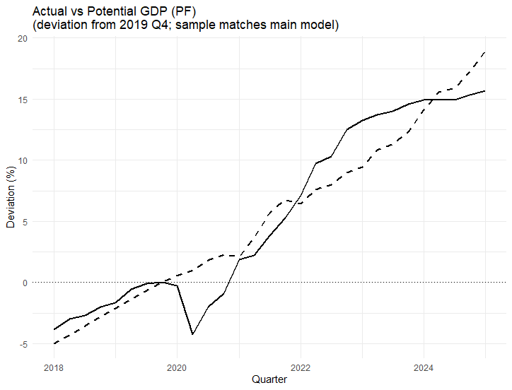

Several features of these results are noteworthy. First, the timing, sign, and magnitude of the estimated output gap closely align with major economic events affecting Bosnia and Herzegovina over the sample period. Second, the smooth behavior of potential output prevents the misinterpretation of short-term rebounds as permanent increases in productive capacity. Third, by explicitly modeling factor inputs and trend productivity, the production function approach delivers transparent and economically interpretable estimates of both potential output and cyclical slack.

Figure: Output gap (PF, using seasonally adjusted real GDP)

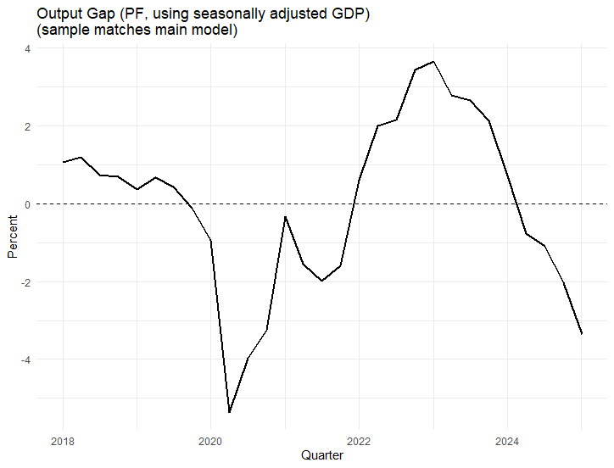

Overall, the production function estimates provide a coherent and informative characterization of Bosnia and Herzegovina’s macroeconomic dynamics. They constitute one of the key empirical contributions of the paper and offer a solid foundation for subsequent analysis of business-cycle conditions.

4.2. Model Based Results
Figure X summarizes the key empirical results obtained from the estimated currency-board version of the semi-structural Laubach–Williams (LW) model for Bosnia and Herzegovina. The four panels jointly characterize the evolution of actual and potential output, cyclical economic conditions, financial risk premia, and trend growth over the sample period.
The top-left panel depicts actual and potential real GDP, expressed as deviations from a common base period (2019). Actual output exhibits pronounced cyclical fluctuations, most notably a sharp contraction during the COVID-19 crisis followed by a strong post-pandemic recovery. Potential output evolves smoothly over time, reflecting the model’s interpretation of potential as a slow-moving component driven by trend growth rather than short-term demand shocks. The temporary divergence between actual and potential output around the crisis period highlights the model’s ability to separate cyclical disruptions from underlying productive capacity. Importantly, the post-2021 convergence of actual output back toward potential suggests that the recovery was largely cyclical rather than driven by a permanent upward shift in potential output.
The top-right panel presents the estimated output gap, defined as the deviation of actual output from its potential level. The output gap remains close to zero in the pre-pandemic period, indicating broadly balanced cyclical conditions. During the COVID-19 shock, the gap turns sharply negative, reaching its trough in 2020, consistent with the sudden collapse in economic activity. The subsequent rebound is rapid and pronounced, with the output gap turning positive during 2021–2022, reflecting strong demand pressures during the recovery phase. More recently, the gap narrows again toward zero, suggesting a gradual normalization of cyclical conditions. Overall, the estimated output gap aligns well with the known chronology of economic shocks and recoveries, lending credibility to the model’s cyclical decomposition.
The bottom-left panel displays the estimated domestic risk premium component ($ρ_{t}$​), expressed as deviations from its long-run mean. This component captures time-varying financial conditions and risk perceptions affecting the domestic economy under the currency board regime. The premium rises prior to the COVID-19 crisis, signaling a gradual tightening of financial conditions and increasing risk perceptions. During the crisis, the premium falls sharply below its mean, reflecting extraordinary external financial support, global monetary easing, and temporary compression of risk spreads. In the post-pandemic period, the premium increases again, peaking during 2022 amid global monetary tightening and heightened uncertainty, before gradually declining thereafter. The dynamics of the risk premium closely mirror periods of financial stress and easing observed in regional and global markets, underscoring its role as a key transmission channel of external financial shocks to the domestic economy.
Figure: Output, Potential, and Financial Conditions in Bosnia and Herzegovina
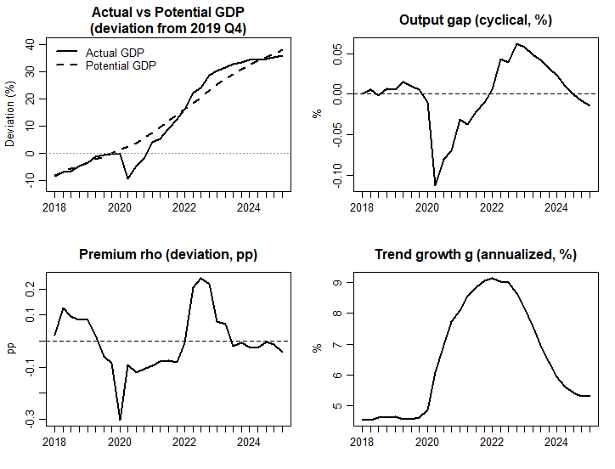
The bottom-right panel shows the estimated trend growth rate of potential output, expressed in annualized terms. Trend growth is relatively stable and moderate prior to the pandemic, reflecting structural constraints typical of a small open economy. During the recovery phase, trend growth rises markedly, peaking around 2021–2022. This increase likely reflects a combination of post-crisis normalization effects, temporary efficiency gains, and favorable external conditions rather than a permanent acceleration in long-run growth potential. Subsequently, trend growth declines toward more moderate levels, suggesting that the post-pandemic surge was largely transitory. The smooth yet time-varying nature of trend growth highlights the importance of allowing for gradual structural changes while avoiding the misinterpretation of cyclical rebounds as permanent shifts in potential output.
Taken together, the four panels provide a coherent and internally consistent narrative of Bosnia and Herzegovina’s recent macroeconomic dynamics under a currency board arrangement. The model successfully disentangles cyclical fluctuations from structural trends, captures the role of financial risk premia in shaping economic conditions, and delivers economically interpretable estimates of potential output and trend growth. These results form the foundation for the subsequent analysis of the natural real interest rate, which builds directly on the estimated trend growth and risk premium components to characterize equilibrium financial conditions in the absence of independent monetary policy.

4.2.1. Natural Real Interest Rate under a Currency Board Arrangement
Figure X presents the estimated natural real interest rate for Bosnia and Herzegovina, defined as the sum of the euro-area neutral real rate and a country-specific risk-premium component. In a currency board arrangement, the natural real interest rate is the real interest rate consistent with output at its potential level and with external financial balance, in the sense that it does not generate persistent capital inflows or outflows. Formally, the natural rate is given by
$$r_{t}^{*}=r_{EA,t}^{*}+ρ_{t}$$
where $r_{EA,t}^{*}$ denotes the euro-area natural real interest rate and $ρ_{t}$ captures time-varying domestic financial and risk conditions.
This definition reflects the institutional features of a currency board regime. Since Bosnia and Herzegovina does not conduct an independent monetary policy and domestic interest rates are largely determined by external financial conditions, the euro-area natural rate serves as the fundamental anchor for domestic real interest rates. However, capital flows, risk perceptions, and financial frictions introduce a wedge between domestic and euro-area financial conditions. The estimated risk premium $ρ_{t}$​ represents this wedge and constitutes the primary channel through which the domestic economy restores both internal and external balance.
Importantly, the risk premium plays a dual role in the framework. On the one hand, it acts as an endogenous equilibrium adjustment variable, ensuring that the real interest rate is consistent with output at potential and the absence of persistent capital-flow pressures. On the other hand, the premium also reflects exogenous fluctuations in financial risk, driven by changes in global risk appetite, regional financial stress, and country-specific uncertainty. As a result, movements in $ρ_{t}$​ combine equilibrium adjustment dynamics with independent financial shocks. This dual interpretation is particularly relevant for Bosnia and Herzegovina, where domestic financial conditions are strongly influenced by regional and global factors beyond the control of domestic policymakers.

Figure: BH and EA natural interest rates
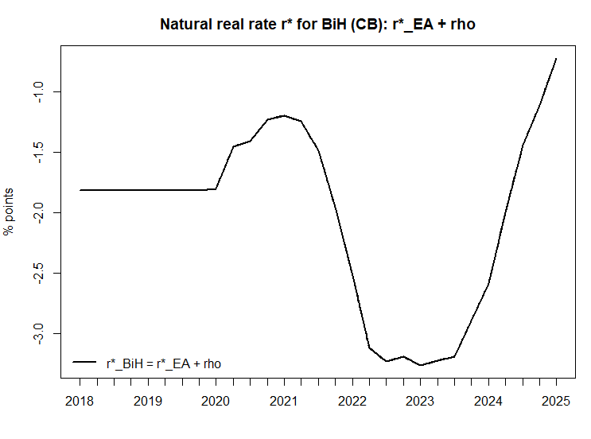

The estimated natural real interest rate displays economically meaningful variation over time, driven by the interaction between the euro-area neutral real rate and the country-specific risk-premium component. In the period preceding the COVID-19 crisis, the natural rate remains broadly stable at moderately elevated levels, reflecting relatively favorable external financing conditions and contained risk perceptions. The close alignment between the domestic and euro-area natural rates during this period underscores the dominant role of external monetary and financial conditions under the currency board arrangement.
At the onset of the COVID-19 pandemic, the natural rate declines sharply, reaching a pronounced trough in 2022–2023. This decline is driven primarily by a substantial deterioration in euro-area real financial conditions, amplified by a temporary increase in domestic risk perceptions. Heightened uncertainty, disruptions to cross-border capital flows, and a sharp contraction in economic activity jointly lowered the real interest rate consistent with macroeconomic equilibrium under the currency board. Importantly, while the risk premium contributes to the decline, the bulk of the movement reflects the collapse in the external real rate anchor rather than implausibly large domestic financial distortions.
As the recovery gained momentum in 2021–2022 and especially from 2023 onward, the natural rate increased sharply. This rise is driven predominantly by the rapid normalization and subsequent tightening of euro-area real interest rates, reflecting higher global inflation, restrictive monetary policy in advanced economies, and a re-pricing of global risk-free rates. The domestic natural rate closely tracks this upward adjustment, with deviations from the euro-area benchmark remaining limited in magnitude. This pattern indicates that the post-pandemic increase in the natural rate is anchored in external monetary conditions rather than in an exceptional compression of domestic risk premia.
Unlike model-implied natural rate estimates derived mechanically from domestic output-gap dynamics, the level-based measure presented here remains tightly anchored to observable financial conditions. In particular, the euro-area natural rate evolves smoothly and within a plausible range relative to short-term money-market rates, while the domestic natural rate deviates from this anchor only to the extent implied by movements in the estimated risk premium. This construction avoids implausibly large swings in the natural rate—such as excessively deep negative values during the COVID-19 period—that can arise when realized inflation or cyclical output measures are used directly to infer equilibrium interest rates.
The resulting behavior of the natural rate is therefore best understood through the lens of external balance rather than intertemporal demand stabilization. In a small open economy operating under a fixed exchange rate, equilibrium real interest rates are shaped predominantly by external financial conditions and cross-border capital flows. Periods of global monetary easing and heightened risk aversion lower the externally consistent real rate, while phases of global tightening raise it, largely independent of domestic cyclical conditions. The observed co-movement between the domestic natural rate and the euro-area benchmark thus reflects the financial transmission of external shocks rather than endogenous monetary policy responses.
Overall, the estimated natural real interest rate provides a coherent and institutionally consistent characterization of monetary-financial conditions in Bosnia and Herzegovina. By anchoring the domestic natural rate to the euro-area benchmark and allowing for time-varying risk premia, the approach captures the dominant role of external financial forces in shaping macroeconomic adjustment under a currency board regime. The resulting estimates are both economically plausible and policy-relevant, offering a more credible measure of equilibrium real interest rates than purely model-implied alternatives in an environment where conventional monetary policy instruments are unavailable.

5. Robustness Analysis
Given the inherent uncertainty surrounding the estimation of unobserved macroeconomic variables such as potential output, trend growth, and the output gap, this section evaluates the robustness of the empirical findings along several complementary dimensions. Specifically, it examines whether the key conclusions derived from the semi-structural Laubach–Williams–style model are sensitive to alternative detrending techniques, model assumptions, and sources of identifying information. Robustness is assessed by comparing model-based estimates of trend growth and the output gap with corresponding measures obtained from widely used statistical filters and a production-function framework. This multi-pronged approach serves two purposes: first, to verify that the estimated cyclical dynamics are not an artifact of a particular modeling choice; and second, to assess whether the semi-structural framework delivers a plausible balance between smooth trend dynamics and economically meaningful cyclical fluctuations in a small open economy operating under a currency board arrangement.

5.1. Robustness of Trend Growth Estimates
Figure X reports the estimated trend growth rate of potential output together with 95 percent bootstrap confidence intervals. The figure provides an important validation of the model’s interpretation of trend growth dynamics. Prior to the COVID-19 crisis, trend growth is estimated to be relatively stable and precisely identified, reflecting persistent structural constraints. During the post-pandemic recovery, the trend growth estimate rises markedly and the confidence bands widen, indicating increased uncertainty surrounding the decomposition of cyclical and structural forces in an unprecedented environment. While the increase in trend growth during 2021–2022 is statistically significant, the subsequent decline toward more moderate levels lies well within the estimated confidence intervals. This pattern supports the interpretation that the post-pandemic acceleration in trend growth was largely transitory rather than indicative of a permanent shift in long-run growth potential. Overall, the confidence bands confirm that the model allows for time variation in trend growth while maintaining sufficient discipline to avoid attributing short-term cyclical rebounds to lasting structural changes.
Figure: Trend growth (annualized, in %) with 95% bootstrap CIs
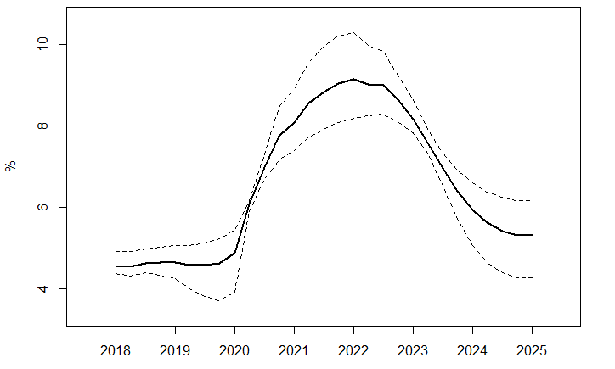
As a robustness check, Figure X compares the output gap obtained from the semi-structural Laubach–Williams model with a purely statistical output gap derived from the Hodrick–Prescott (HP) filter using a standard quarterly smoothing parameter (λ = 1600). The two measures display a high degree of concordance in both timing and magnitude. In particular, both approaches identify a sharp negative output gap during the COVID-19 crisis in 2020, followed by a rapid closing and a temporary positive gap during the post-pandemic recovery. Differences between the two measures are modest and largely reflect the greater smoothness of the HP filter, especially during the normalization phase after 2022. Overall, the close co-movement between the LW and HP output gaps supports the robustness of the model-based cyclical decomposition and indicates that the main results are not driven by the specific structure of the semi-structural model.

5.2. Robustness of the Gap Estimates
To assess the robustness of the model-based output gap derived from the semi-structural Laubach–Williams (LW-style) framework adapted for a currency board regime, the estimated gap is compared with three widely used alternative measures: (i) the Hodrick–Prescott (HP) filter with a smoothing parameter λ = 1600, (ii) a band-pass filter targeting business-cycle frequencies of 6–32 quarters, and (iii) an output gap obtained from a production-function (PF) approach. All series are expressed in percentage deviations from potential output and aligned to a common quarterly sample.
Several key findings emerge from this comparison. First, the cyclical timing of the model-based output gap is highly consistent across all methods. All gap measures identify a pronounced negative output gap during the Covid-19 shock in 2020, followed by a strong cyclical recovery peaking in 2022–2023 and a subsequent moderation toward the end of the sample. This concordance suggests that the semi-structural model captures the dominant business-cycle dynamics observed in Bosnia and Herzegovina, despite its more restrictive structural assumptions imposed by the currency board setting.

Figure: Output gap comparison using different methodologies
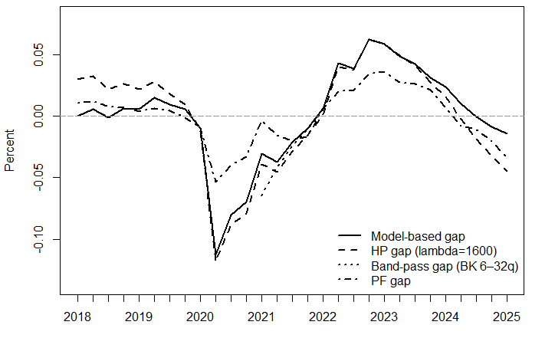

Second, the magnitude of cyclical fluctuations differs systematically across methods, in line with theoretical expectations. The HP-filtered gap exhibits smoother dynamics and attenuated amplitudes, reflecting its purely statistical nature and well-known end-point smoothing. In contrast, the band-pass ffilter produces somewhat larger cyclical swings, particularly around turning points, as it isolates medium-term fluctuations more aggressively while discarding low-frequency trend movements. Importantly, once the band-pass filter is implemented with a reduced endpoint trimming (Option B), its estimated cycle closely tracks the model-based gap over the central part of the sample, both in terms of sign and relative amplitude.
Third, the production-function gap aligns closely with the semi-structural model during the post-pandemic period, although it displays slightly milder contractions during the Covid-19 downturn. This difference likely reflects the slower adjustment of factor inputs—particularly labor—embedded in the PF framework, which is consistent with the institutional characteristics of the Bosnian labor market and the use of administrative employment measures. By contrast, the LW-style model allows for sharper cyclical responses through the output gap and trend-growth channels, capturing the abrupt collapse in demand during the pandemic more forcefully.
Overall, the robustness exercise indicates that the model-based output gap is neither an outlier nor excessively volatile relative to standard filtering approaches. Instead, it lies between the smoother HP gap and the more volatile band-pass gap, while remaining broadly consistent with the production-function estimate. This pattern is economically intuitive and supports the interpretation of the semi-structural gap as a balanced measure that combines economic structure with empirical flexibility.
Taken together, these results suggest that the main conclusions drawn from the model-based output gap—regarding the timing, depth, and persistence of cyclical fluctuations in Bosnia and Herzegovina—are robust to alternative detrending and filtering methods. The close co-movement across gap measures strengthens confidence in the empirical relevance of the proposed LW-style framework for a small open economy operating under a currency board regime.

5.3. Robustness of the Natural Interest Rate Estimates
As a robustness check, this paper evaluates the uncertainty surrounding the estimated natural real interest rate by constructing confidence intervals that explicitly account for measurement uncertainty in the financial spread used to identify the country-specific risk premium. In the baseline specification, the natural rate for Bosnia and Herzegovina is defined as the sum of the euro-area neutral real rate and a time-varying domestic risk premium. While the euro-area component is treated as a smoothly evolving external anchor, uncertainty in the domestic natural rate is driven primarily by the estimation of the risk premium.
In small open economies, observed financial spreads—such as sovereign CDS or closely related proxies—are subject to non-trivial measurement error arising from market illiquidity, episodic trading, interpolation from higher-frequency data, and the use of regional rather than strictly domestic instruments. Estimating the measurement variance of such spreads within a state-space model often leads to near-zero estimates, artificially collapsing the uncertainty around the inferred risk premium and, by extension, the natural rate. To avoid this well-known problem, the robustness exercise follows a standard practice in the applied state-space literature by fixing the measurement error variance of the spread equation at a plausible level rather than estimating it freely.
Specifically, the measurement standard deviation of the spread equation is fixed at 25 basis points, corresponding to moderate but economically reasonable uncertainty in quarterly financial spreads. This calibration is conservative in the sense that it allows for substantial noise in observed spreads without dominating the signal used to identify the risk-premium state. Similar calibrations are commonly employed in semi-structural and unobserved-components models of interest rates and financial conditions, particularly when financial variables are used as imperfect proxies for latent risk premia.
Figure X presents the resulting natural real interest rate for Bosnia and Herzegovina together with its 95 percent confidence interval. The confidence band is driven exclusively by uncertainty in the estimated risk premium, while detached from the euro-area anchor, which evolves smoothly and remains well-behaved. Importantly, the confidence interval is narrow enough to preserve the qualitative dynamics of the natural rate, yet wide enough to reflect meaningful estimation uncertainty. The implied range comfortably excludes implausibly extreme values—such as excessively deep negative natural rates during the COVID-19 period—while still capturing the pronounced decline associated with heightened financial stress and the subsequent recovery as global conditions normalized.

Figure: Natural interest rate with 95% Cis
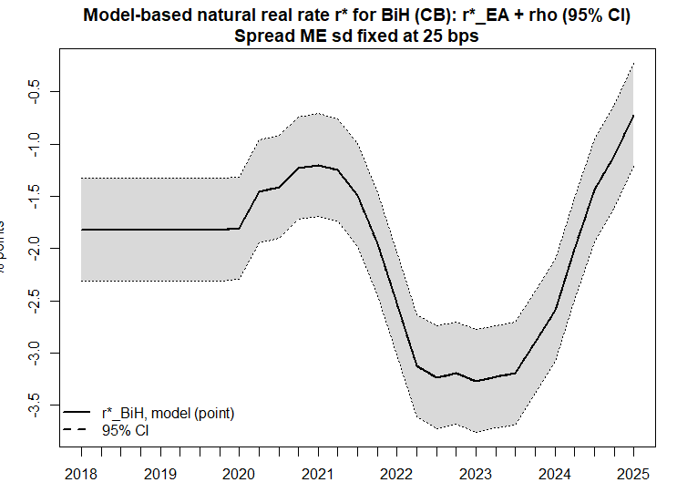
Overall, this robustness exercise confirms that the estimated natural real interest rate is not an artifact of overly tight statistical assumptions. Instead, its dynamics remain stable and economically interpretable under alternative, more realistic assumptions about financial-spread measurement uncertainty. The results reinforce the conclusion that the natural rate in Bosnia and Herzegovina is predominantly shaped by external monetary conditions and time-varying risk premia, consistent with the institutional constraints imposed by the currency board regime.

6. Conclusion

This paper set out to estimate potential output, trend growth, and cyclical economic conditions in Bosnia and Herzegovina, an economy operating under a currency board arrangement and subject to pronounced external shocks. Estimating these unobserved macroeconomic concepts is inherently challenging, particularly in small open economies with constrained monetary policy frameworks and relatively short data samples. To address these challenges, the paper adopted a multi-method empirical strategy combining statistical filtering techniques, a production function approach, and a semi-structural multivariate state-space model in the spirit of Laubach and Williams.
The empirical analysis demonstrates that no single methodology can fully capture the complexity of trend–cycle dynamics in isolation. Univariate statistical filters provide transparent and easily replicable benchmarks but remain vulnerable to end-point bias and the misclassification of large temporary shocks. The production function framework offers an economically grounded decomposition of output based on factor inputs and trend productivity, yielding smooth and interpretable estimates of potential output. However, it remains sensitive to assumptions regarding labor market slack, capital accumulation, and trend extraction. These limitations underscore the value of complementing traditional approaches with a multivariate framework that explicitly links output dynamics to inflation and financial conditions.
The central contribution of the paper lies in the development and application of a semi-structural Laubach–Williams–style model adapted to the institutional realities of a currency board economy. By excluding a domestic monetary policy reaction function and emphasizing external financial conditions and time-varying risk premia, the model captures key transmission channels relevant for Bosnia and Herzegovina. The framework delivers economically intuitive and internally consistent estimates of potential output, trend growth, the output gap, and the natural real interest rate, while allowing for gradual structural change without conflating cyclical rebounds with permanent shifts in productive capacity.
The results highlight the pivotal role of financial conditions in shaping business-cycle dynamics under a fixed exchange rate regime. The estimated output gap closely aligns with major economic episodes, including the Global Financial Crisis and the COVID-19 shock, while trend growth is allowed to vary over time in a disciplined manner. The natural real interest rate is driven predominantly by movements in a time-varying risk premium, reflecting shifts in global risk appetite, regional financial stress, and external monetary conditions. This finding reinforces the view that, in the absence of independent monetary policy, macroeconomic adjustment in currency board economies operates primarily through financial and external channels rather than through domestic policy rates.
Robustness exercises confirm that the main conclusions are not sensitive to a particular detrending technique or modeling choice. Model-based estimates of the output gap display a high degree of concordance with alternative measures derived from Hodrick–Prescott filtering, band-pass filtering, and the production function approach. Differences in amplitude and smoothness across methods are consistent with their underlying assumptions and well documented in the literature. The close co-movement across approaches strengthens confidence in the empirical relevance of the semi-structural framework and supports its use as a balanced measure of cyclical economic slack.
From a policy perspective, the findings carry several important implications. First, reliance on purely statistical filters may lead to misleading assessments of economic slack during periods of large shocks, particularly in economies undergoing structural change. Second, production function estimates provide valuable insights into supply-side constraints but should be interpreted alongside multivariate evidence on demand and financial conditions. Third, for currency board economies, monitoring financial risk premia and external conditions is essential for assessing cyclical pressures and equilibrium interest rates, as these variables effectively substitute for conventional monetary policy instruments.
More broadly, the paper contributes to the growing literature on potential output estimation in developing and transition economies by demonstrating that semi-structural state-space models—when appropriately adapted—can provide meaningful insights even in environments where standard monetary transmission mechanisms are weak or absent. Future research could extend this framework by incorporating richer financial indicators, exploring real-time estimation properties, or embedding fiscal policy variables to assess interactions between cyclical conditions and fiscal stance. Such extensions would further enhance the usefulness of semi-structural models as practical tools for macroeconomic surveillance and policy analysis in small open economies.

References
Baxter, M., & King, R. G. (1999). Measuring business cycles: Approximate band-pass filters for economic time series. Review of Economics and Statistics, 81(4), 575–593.
Borio, C., Disyatat, P., & Juselius, M. (2017). Rethinking potential output: Embedding information about the financial cycle. Oxford Economic Papers, 69(3), 655–677.
Christiano, L. J., & Fitzgerald, T. J. (2003). The band pass filter. International Economic Review, 44(2), 435–465.
Clark, P. K. (1987). The cyclical component of U.S. economic activity. Quarterly Journal of Economics, 102(4), 797–814.
Cogley, T. (2002). A simple adaptive measure of core inflation. Journal of Money, Credit and Banking, 34(1), 94–113.
Giannone, D., Lenza, M., & Primiceri, G. E. (2023). KFAS: Exponential family state space models in R (R package version 1.6.0) [Computer software]. CRAN. https://CRAN.R-project.org/package=KFAS
Gordon, R. J. (1997). The time-varying NAIRU and its implications for economic policy. Journal of Economic Perspectives, 11(1), 11–32.
Harvey, A. C. (1989). Forecasting, structural time series models and the Kalman filter. Cambridge: Cambridge University Press.
Harvey, A. C., & Jaeger, A. (1993). Detrending, stylized facts and the business cycle. Journal of Applied Econometrics, 8(3), 231–247.
Hodrick, R. J., & Prescott, E. C. (1997). Postwar U.S. business cycles: An empirical investigation. Journal of Money, Credit and Banking, 29(1), 1–16.
IMF. (2015). Where are we headed? Perspectives on potential output. World Economic Outlook, April. Washington, DC: International Monetary Fund.
Laubach, T., & Williams, J. C. (2003). Measuring the natural rate of interest. Review of Economics and Statistics, 85(4), 1063–1070.
Laubach, T., & Williams, J. C. (2016). Measuring the natural rate of interest: International trends and determinants. Journal of International Economics, 108(S1), S59–S75.
Perron, P. (1989). The great crash, the oil price shock, and the unit root hypothesis. Econometrica, 57(6), 1361–1401.
Ravn, M. O., & Uhlig, H. (2002). On adjusting the Hodrick–Prescott filter for the frequency of observations. Review of Economics and Statistics, 84(2), 371–376.
Staiger, D., Stock, J. H., & Watson, M. W. (1997). The NAIRU, unemployment and monetary policy. Journal of Economic Perspectives, 11(1), 33–49.
Stock, J. H., & Watson, M. W. (1999). Forecasting inflation. Journal of Monetary Economics, 44(2), 293–335.
Stock, J. H., & Watson, M. W. (2002). Has the business cycle changed and why? NBER Macroeconomics Annual, 17, 159–218.

The SDMX interface is a standardized, machine-readable gateway that allows researchers to programmatically access official macroeconomic and financial statistics from institutions such as the ECB, IMF, and Eurostat.
The parameter 𝛾 is calibrated rather than estimated and is set to 0.25, a standard value in the literature capturing partial pass-through of euro-area inflation to domestic prices in small open economies.
This specification corresponds to the logarithmic transformation of a standard Cobb–Douglas production function $Y_{t}=A_{t}K_{t}^{α}L_{t}^{1-α}$​, where $A_{t}$ denotes total factor productivity.
KFAS package for R provides a flexible framework for estimating linear and nonlinear state-space models via the Kalman filter and smoother, allowing for diffuse initialization, time-varying system matrices, and maximum-likelihood estimation of unknown variances. KFAS is particularly well suited for semi-structural macroeconomic models with unobserved components, such as the Laubach–Williams framework. See Giannone, Lenza, and Primiceri (2023) for technical details and implementation.
Given their relative simplicity, the results obtained from the filtering techniques are not presented in a separate section. Instead, they are used as benchmark estimates against which the results of the more structurally rich approaches are evaluated.
The euro-area natural real interest rate is obtained from a local-level state-space model applied to the observed euro-area real short-term interest rate. Specifically, the real rate is decomposed into a permanent component following a random walk and a transitory disturbance. The permanent component, estimated using the Kalman filter and smoother, is interpreted as the euro-area natural real interest rate. This specification allows the natural rate to evolve gradually over time in response to structural factors, while filtering out high-frequency cyclical and financial shocks.

